Brihaspathi Technologies Limited

SITE SURVEY FORM

PROJECT DETAILS-
Name
Project Location
Prepared By
Date
SFA Lead Number

CUSTOMER DETAILS-
Name
Site Address
City
State
Pin code

CUSTOMER REQUIREMENT-
Requirement of Solar Power Plant Capacity (KWp)
Type of Solar Plant (On Grid / Off Grid / Hybrid )

SITE DETAILS-
Latitude / Longitude Coordinates of site
Power Evacuation Voltage – LT / Medium
Sanctioned Load/Connected Load
Type of Roof- RCC/Slant Shed/ Ground Mount
Building Height
Total number of roofs

ROOF DETAILS-
1) RCC Roof
Is chipping allowed?
Is drilling allowed?
Pls clear obstacles details like Mumty, Lift, Water
Tank, Parapet Wall, Piping, Trees, etc
2) Slant Shed
Select kind of Shed-
a) Trapezoidal | 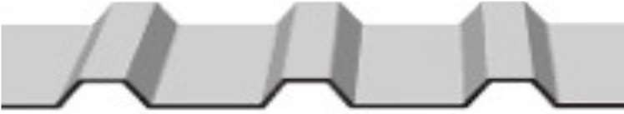
b) Trapezoidal PUF |   
c) Standing Seam profile | 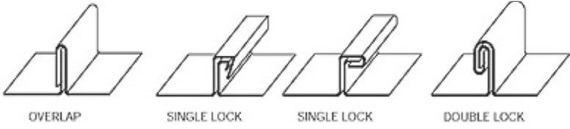  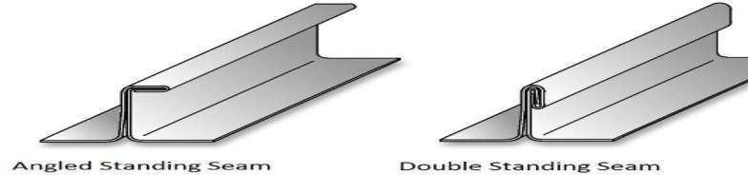
Is penetration of Sheet allowed? | NA
Slope angle of Shed? | NA
Thickness of Sheet (mm) | NA
Purlin to Purlin Distance | NA
Pls clear obstacles details like Ventilators/Light  Falls/Chimneys/etc | NA
SAFETY ITEMS-
Walkway/Safety Line/Water Line/ MS Staircase/  Ladder/Inverter Stand | Parapet Wall exists on the perimeter of the roof

3) Ground Mount
Soil Test Report | NA
Is Land Levelling required? | NA
Solar requirement for open ground or for Carport | NA

ELECTRICAL DETAILS-
COMPONENTS-
Type of Solar Module to be used (Poly/Mono) | MONO
Is overloading of Inverter allowed?
Availability of Spare Feeders & its rating
Placement of DCDB, Inverter & ACDB- Ground
Floor/Rooftop/define as per site
Availability of Internet connection
CABLES & EARTHING-
Distance from PV Module to DCDB
Distance from DCDB to Inverter
Distance from Inverter to ACDB
Distance from ACDB to LT Panel
Distance of communication cable from Inverter to
Router
EARTHING-
Placement of Lightning arrestor
Is existing LA on site?
Existing Cable Tray/Trench
DIESEL GENERATOR & OTHERS-
Availability of DG
Quantity & Rating
Requirement of DG PV Management
Controller
Requirement of Weather Monitoring Station
Net Metering / Zero Export facility

TRANSFORMER-
Name of manufacturer
KVA Rating
No of Phase
Rated frequency
Rated Voltage (KV)
DOCUMENTS TO BE ATTACHED WITH THIS SITE  SURVEY FORM- | Mark Tick
1) Auto Cad Drawing with its Sectional Layout
in dwg format
2) If Auto Cad is not available, Dimensional
Layout to be provided with every obstacles details
3) Photographs of site
4) Electrical Single Line Diagram of Site
5) Google Earth image indicating roofs to be
used & LT Panel
6) Cable routing Plan for DC & AC Cable
7) Electricity Bill Copy

Remarks if any:

Brihaspathi Rep Name: Customer Rep Name:

Mobile no: Mobile no:

Signature: Signature:

Date: Date:

